**Apruvd**

Integration Documentation

Prepared by Milan Panic

OSF Global Services

Table of Contents

1. Summary 4

2. Component overview 4

2.1 Functional overview 4

2.2 Compatibility 5

2.3 Availability 5

2.4 Limitations, constraints 5

2.5 Privacy, Payment 5

3. Implementation guide 5

3.1 Setup 5

3.2 Configuration 6

Add cartridges to cartridge path 6

Import metadata 7

Configure Apruvd custom site preferences 7

Configure products 9

Configure shipping methods 9

3.3 Custom code 10

SiteGenesis code changes 10

SFRA code changes 11

3.4 External interfaces 11

3.5 Testing 11

4. Operations, maintenance 12

4.1 Data storage 12

4.2 Support 13

5. User guide 13

5.1 Roles, responsibilities 13

5.2 Business manager 14

5.3 Storefront functionality 14

6. Known issues 14

Revision History

|  |  |  |  |
| --- | --- | --- | --- |
| **Name** | **Date** | **Reason For Changes** | **Version** |
| Milan Panic | 13-FEB-2019 | Initial changes | 20.1 |
| Milan Panic | 28-AUG-2020 | Support for using Apruvd as second fraud detection tool |  |

# Summary

Apruvd is a fraud protection service for businesses that provides solution for fraud screening allowing clients to review and update transactions. The Apruvd cartridge will be integrated into Salesforce Commerce Cloud supporting Apruvd API V3 and v4.

The implementation will include using different service plans for client account, job schedules for re-sending transactions that have failed during order creation as well as Business Manager module for searching orders, submitting transactions and elevating.

This document primarily serves as the LINK implementation guide for setting up Apruvd on Storefront Reference Architecture (SFRA) and SiteGenesis Controllers architecture.

# Component overview

## Functional overview

Main features of the Apruvd cartridge are following:

* Business Manager Configuration Page: all settings can be configured through Apruvd group in Custom Site Preferences
* Transaction creation: Transactions are automatically created when an order is created according to service plan and merchant settings
* Transaction re-creation job: Transactions that couldn’t be created will be submitted again in scheduled job
* Business Manager Module: Apruvd Business Manager Module provides order search functionality with possibility to submit or elevate order transactions.
* Apruvd can be used as second fraud detection tool, so that Apruvd will check only orders that are explicitly marked for review
* All the features above work with all locales.

## Compatibility

Apruvd integration is available starting Salesforce Commerce Cloud version 19.3.

Compatible with version 4.2.0 and 4.3.0 of the SFRA storefront.

## Availability

In case when Apruvd service is not responding customers will be able to finish checkout and the order will be created and placed without any apruvd specific attributes.   
Such orders are handled in **Apruvd-CreateMissingTransactions** job: the scheduled job will try to re-create transaction to Apruvd and update orders.

## Limitations, constraints

The Apruvd cartridge supports only one pair of authorization keys for Apruvd webhooks.

The Apruvd cartridge doesn’t send all possible parameters during transaction creation due to platform limitations, for example first 6 credit card digits, payment processor response etc. After a payment processor is chosen and integrated it is recommended to add those fields according to Apruvd documentation if possible.

## Privacy, Payment

Order data including customer address, email, credit card type and last 4 digits are sent to Apruvd during transaction creation.

# Implementation guide

## Setup

Apruvd integration has two cartridges:

* int_apruvd
* bm_apruvd

ZIP archive has following structure:

* /documentation - folder with cartridge documentation
* /cartridges – folder with int_apruvd and bm_apruvd cartridges
* /metadata – folder with metadata changes, services and jobs for import

## Configuration

### Add cartridges to cartridge path

The Apruvd cartridges need to be added to cartridge path under **Administration** > **Sites** > **Manage Sites**:

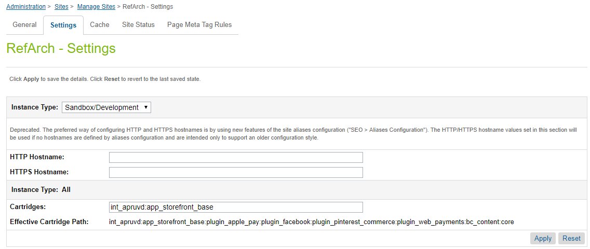

The cartridge path for SFRA, SiteGenesis and Business Manager after the change should be respectively:

* int_apruvd_sfra:int_apruvd:app_storefront_base
* int_apruvd:app_storefront_controllers:app_storefront_core
* bm_apruvd:int_apruvd:bm_custom_plugin

### Import metadata

Under **Administration** > **Site Development** > **Import & Export**

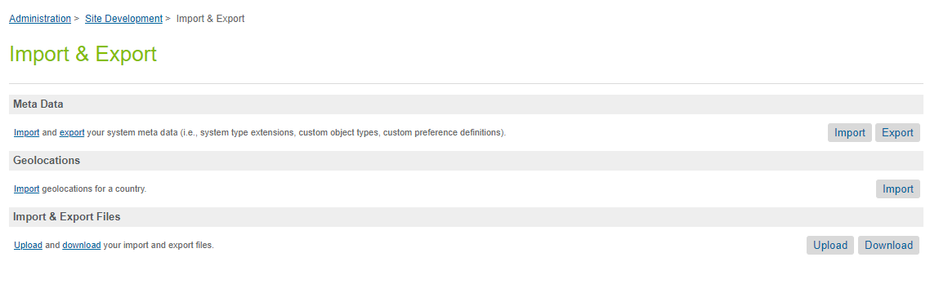

Upload and import metadata.xml from metadata folder.

Go to **Administration** > **Operations** > **Import & Export**

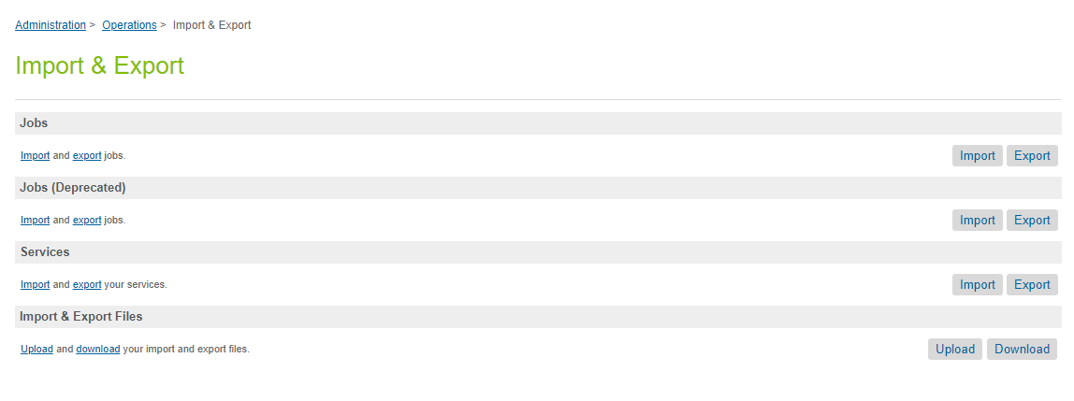

Upload and import services.xml and jobs.xml from metadata folder.

### Configure Apruvd custom site preferences

Go to **Merchant Tools** > **Site Preferences** > Cu**stom Site Preference Groups** and find preference group Apruvd and populate correct values:

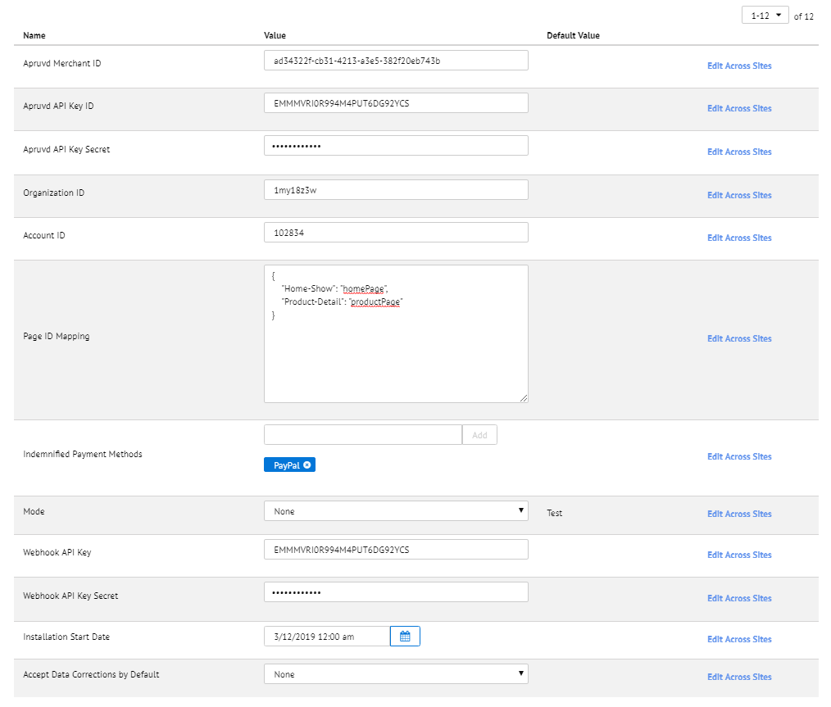

Values for fields ***Apruvd Merchant ID***, ***Apruvd API Key ID***, ***Apruvd API Key Secret***, ***Organization ID***, ***Account ID***are provided by Apruvd during registration.

If ***Use Apruvd as Second Fraud Detection*** is true, orders will be sent to Apruvd for review only if they are explicitly marked for Apruvd review in one of the two ways:

* by calling hook in the code for real time transaction creation: HookMgr.callHook('apruvd.transaction.api', 'trigger', order);  
  where order represents SFCC order object
* by marking custom attribute apruvdCheckOrder as true and running Apruvd-CreateMissingTransactions job:  
  order.custom.apruvdCheckOrder = true;

***Page ID Mapping***contains a JSON with mapping controller calls to page IDs that will be used in Apruvd script call, e.g.:

<script type="text/javascript" src="https://content.apruvd.com/fp/tags?org_id=1my18z3w&amp;session_id=u2EoTZ6-7_7AWZke7TUS6uk9sKaisPu-En8=&amp;page_id=homePage"></script>

If a specific page ID is not mapped in the preference, controller call will be used instead.

***Indemnified Payment Methods*** contains payment methods that are guaranteed against fraud risk. If order contains such payment method, the order won’t be elevated for Apruvd review.

Some of the well-known providers of indemnified payments are:

Pay with Amazon

Webinterpret

Affirm

Houzz

***Webhook API Key*** and ***Webhook API Key Secret*** are used for authorization when webhooks from Apruvd are sending requests to SFCC endpoints. These two values are defined during Webhook creation in Apruvd console.

***Installation Start Date*** is used for determining which orders are historical and which orders are sent to Apruvd for review.

***Accept Data Corrections by Default*** determines if order data corrections that come from Apruvd should automatically change order object in SFCC. If ‘No’ is selected, data corrections will be available in order notes.

### Configure products

If a product is considered high risk for fraud, on Product level set Is High Risk under Apruvd group to true:

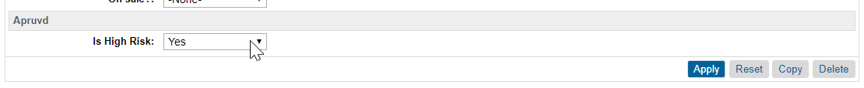

### Configure shipping methods

On shipping method level select one of the values for Apruvd Shipping Speed (if none value is chosen, Standard will be default):

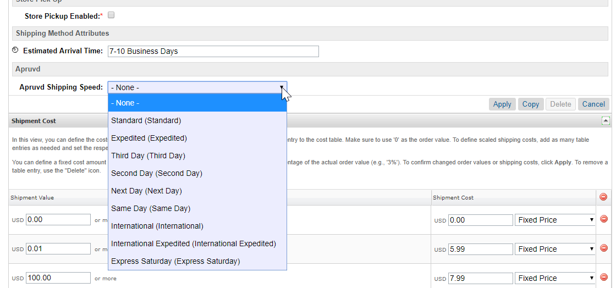

## Custom code

### SiteGenesis code changes

#### Controllers

In **COSummary.js** controller at line 71 after Order is placed add following code:

if (dw.system.Site.current.preferences.custom.apruvdMerchantId) {

var apruvd = require('int_apruvd/cartridge/scripts/service/apruvd');

if (apruvd.isSendTransaction()) {

apruvd.createTransaction(placeOrderResult.Order);

}

}

#### Templates

In **htmlhead.isml** template at the bottom of the file add following code:

<isinclude url="${URLUtils.url('Apruvd-GetScript', 'pageId', require('int_apruvd/cartridge/scripts/service/apruvd').getPageId(request.session.clickStream.last.pipelineName), 'tag', '')}" />



In **footer.isml** template at the bottom of the file add following code:

<isinclude url="${URLUtils.url('Apruvd-GetScript', 'pageId', require('int_apruvd/cartridge/scripts/service/apruvd').getPageId(request.session.clickStream.last.pipelineName), 'tag', 'noscript')}" />



### SFRA code changes

There are no code changes required for SFRA integration.

## External interfaces

Communication between Apruvd and SFCC is based on Apruvd API and all outside traffic from SFCC is handled using https protocol. The interfaces endpoints and examples can be find in Apruvd documentation: <https://v4-dev.apruvd.com/docs/>

## Testing

Unit tests cover both v3 and v4 API:

* createTransaction
* getTransaction
* resubmitTransaction
* partialUpdate

To run unit test you can use: npm run test.

<Sample data, test account, test cases, reference to certification requirements>

# Operations, maintenance

## Data storage

Following system object have been extended in SFCC: Product, ShippingMethod, Order, SitePreferences.

Custom object definition is added for apruvdTokens: it contains tokens for authorization and merchant settings from Apruvd side and of the attributes in the object are externally managed:

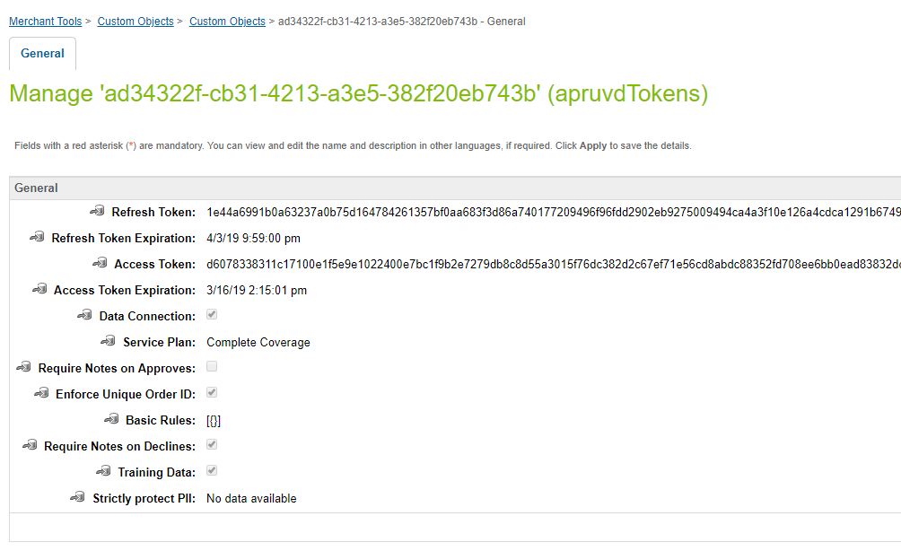

ID of the custom object is Apruvd merchant ID, so it is possible to have only one instance of apruvdTokens custom object per site.

## Support

Please contact Apruvd support in case fixes or improvements are required:

[support@apruvd.com](mailto:support@apruvd.com)

[transactions@apruvd.com](mailto:transactions@apruvd.com)

# User guide

## Roles, responsibilities

Merchants that are responsible for handling orders and sending to Apruvd for review need to have additional Business Manager Modules permissions set for Apruvd Module. The permissions need to be provided by Administrator under: **Administration** > **Organization** > **Roles** > **[name of the role] - Business Manager Modules**

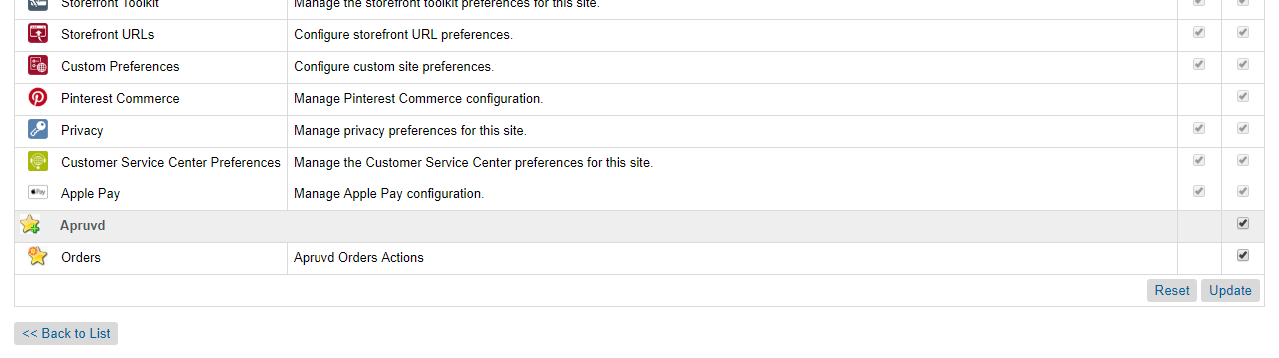

Merchants will then review orders and if needed elevate to Apruvd.

## Business manager

The Business Manager Module is available on Site level and it provides order search and elevate functionality.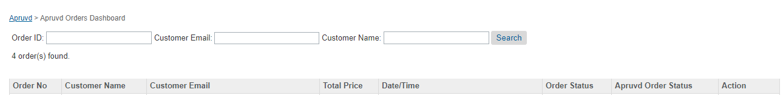

## Storefront functionality

Apruvd cartridge implements communication with Apruvd. When order is placed, transaction is created in Apruvd for fraud protection.

# Known issues

*<List known issues and workarounds>*